**SCHOOL OF COMPUTER SCIENCE**

**UNIVERSITY OF PETROLEUM AND ENERGY STUDIES**

**DEHRADUN, UTTARAKHAND**



**FORM STUDIES**

**Assignment File**

**(2024-2025)**

**For**

**Vth Semester**

**Submitted To: Submitted By:**

Prof. Nikhil Tikhe Mr. Akshat Negi

Assistant Professor S.S. 500106533 (SAP ID)

[Vth Semester] R2142220414 (Roll No.)

School of Design B.Tech. CSF (Batch - 1)

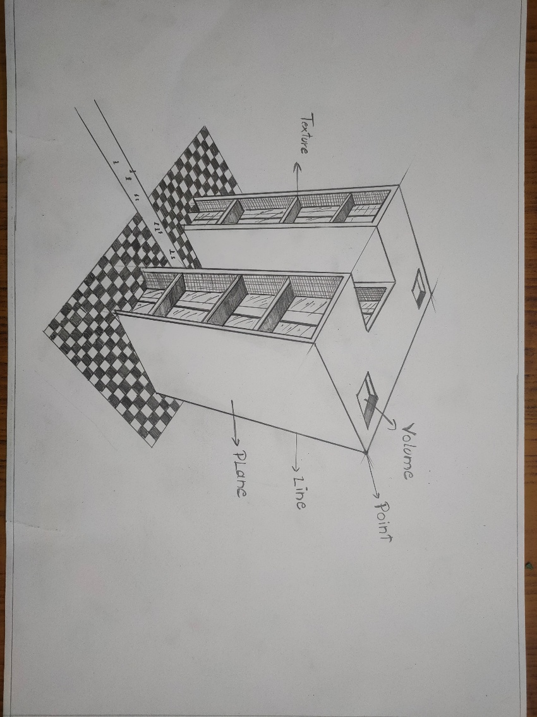**Assignment – 1**

This 3D drawing concept showcases a modern, open-structure building, designed to create an illusion of depth and challenge viewers’ perception of space. The composition draws on minimalistic architectural themes, focusing on how simple forms can convey complexity and intrigue. The artwork uses a unique combination of lines, perspective, and shading to construct a structure that appears to float within its checkerboard foundation, evoking themes of stability and ambiguity.

The conceptual element explores themes of openness and modernity, hinting at the adaptability of architectural spaces to various functional purposes while remaining visually striking. In terms of visual elements, the strong contrasts between light and shadow, as well as the precise perspective, enhance the illusion of three-dimensionality, pulling the viewer’s eye toward the structure and the space within it. Relationally, the checkerboard ground serves as an anchor, establishing a clear spatial boundary that frames the structure while amplifying the surreal nature of the piece. Finally, from a practical standpoint, this composition suggests possibilities for modular, sustainable urban architecture. It reflects the potential for building designs that are both aesthetically pleasing and adaptable to different environments, blending functionality with visual appeal to invite contemplation of future urban landscapes.